Supplement 7

Capacity Planning

**Background**

Even though this is a supplement, it contains enough information to be treated as an independent chapter. The bottleneck analysis material itself could easily be expanded to cover a full class session, particularly if the dice game simulation (see Active Classroom Learning Exercises) is played. Taken together, the tools and concepts in this chapter provide the future operations manager with an excellent starting point for thinking about capacity issues.

**Class Discussion Ideas**

1. One interesting way to demonstrate design and effective capacity is to use the school’s lecture halls as an example. While the design capacity is every seat full for all classes, the effective capacity is considerably less. This can be compared to other services such as airlines or restaurants.

2. A simple question that can generate a long list of ideas is to ask the students for ways in which firms can increase capacity in the short run and the long run. While the distinction between the short and long run is not always clear (and not necessarily that important anyway), the following types of answers might be provided. Short run: using longer production runs implying fewer setups, using overtime, subcontracting, adding shifts, hiring temporary workers, leasing equipment, renting more space, using better or faster workers, eliminating inefficiencies, increasing productivity, improving bottleneck capacity, and decreasing maintenance and/or eliminating inspections and/or eliminating/reducing employee breaks (these last three ideas may have detrimental long-run implications). Long run: purchase new equipment, automate processes, design new processes that are more product focused, expand the permanent workforce, expand facilities, enter into joint ventures, and purchase (merge with) the competition.

3. If the *I Love Lucy* video is shown (see Cinematic Ticklers below), 5-10 minutes of discussion can follow. This clip is as much about poor management techniques as it is about not matching the process time of a station with the speed of incoming product. Ask students what went wrong. They’ll likely identify some of the following. There was no training of the new employees. There was no supervision. We observe “management by threat.” The incentive was only to wrap every candy without letting any get through unwrapped, implying no quality control and encouraging the hiding of mistakes. There was no employee involvement. Communication was one way from the boss to the workers. Communication within the production line was non-existent—if the upstream station knew what was happening, it might have slowed down the line.

**Active Classroom Learning Exercises**

1. Hands-On Simulation of the Dice Game from *The Goal*

The dice game in Chapter 14 in *The Goal (Goldratt and Cox, Third Revised Edition, North River Press, 2004)* can be played in the classroom with groups of five people. The only supplies needed are dice and “products” (matches or pennies, for example). The game as described during the Boy Scout hike in *The Goal* demonstrates the detrimental effects of dependent events and statistical fluctuations on throughput.

The game places five players in a row. The first player has an unlimited supply of raw materials. During each round, player 1 rolls one die and moves that number of products into the raw materials bowl of player 2. Then player 2 rolls the die and moves the minimum of the roll and the number of products in the bowl into the raw materials bowl of player 3. This continues down the line. Player 5’s throughput (minimum of his/her raw materials or die roll) represents the system throughput for that round. The game continues for several rounds, with extra raw materials remaining in bowls in between rounds. The results: throughput will decrease from the start of the line to the end of the line.

The game can be played for several rounds with one group in front of everyone to demonstrate the effects. Then students can be asked to brainstorm ideas for changing the rules of the game to increase throughput. Ideas might include purchasing extra dice (more resources), replacing with bigger (e.g., 12-sided) dice (faster resources), introducing buffer inventory, or flipping a coin (Heads = 3, Tails = 4) (representing more accurate equipment)]. Afterwards, each group can be allowed to “purchase” an option or combination of options. Then let each group play the game for, say, 20 rounds and compare profit results. Revenue is based on throughput times a sales price, and cost depends upon the option purchased. This game can be automated in Excel and played for hundreds of rounds as well (see Additional Assignment Ideas below).

2. While the snowmobile/jet ski example clearly illustrates the concept of complementary demand, both markets already existed so entry was a relatively straightforward exercise. It can be a different proposition when there is no market and the organization has to create one. In the 1960’s Head had a successful business making metal snow skis. However, with no obvious complementary product, they had to create a market for metal tennis rackets in order to develop a complement to their ski production. Have the students investigate the product lines of a few local firms to see if they are using complementary products to balance demand. If they are not, have the students suggest possible complementary products that might be developed or adopted.

**Company Videos**

1. *Capacity Planning at Arnold Palmer Hospital (8:39)*

The Arnold Palmer Hospital was initially built to handle 6500 births per year, but demand soon began to run up against this limit. The hospital decided to build a brand new building across the street from the current one to eventually raise the birthing capacity to 15,000 babies per year. The first nine floors were built in the first phase, and later floors would be completed on an incremental basis as demand continued to rise. The video shows a break-even graph, as well as pictures from the text describing the four different ways to add capacity: (a) leading demand with incremental expansion, (b) leading demand with one-step expansion, (c) lagging demand with incremental expansion, and (d) attempts to have an average capacity with incremental expansion.

Prior to showing the video, instructors could ask students to think about different ways that a hospital might attempt to increase its capacity in terms of number of patients served per year. As the video itself describes several means of incremental and large expansion, discussion following the video could cover the various types. An interesting example is trying to reduce the time in the hospital for patients. What might be done to accomplish that? Are there ethical concerns with trying to move patients through faster? Other ideas could include things like having more shared rooms compared to private rooms, replacing certain hospital services and focus more on a few procedures (for example, eliminating certain surgical procedures that the hospital performs and replacing with more birthing space). Regarding major expansion, such as a new building, an interesting question becomes how large to make it. If the number of births is growing by 600 per year, will that growth continue beyond 10 years, and, if so, should building space (even if empty for the time being) be built at one time? Moreover, is bigger always better? How many births should this hospital perform before it begins to turn customers away?

**Cinematic Ticklers**

1. *I Love Lucy, The Complete Second Season: “Job Switching” (Lucille Ball and Vivian Vance), Paramount, original airdate Sep. 15, 1952*

This classic clip shows Lucy and Ethel wrapping candies on an automatic assembly line. The clip never fails to generate laughter in the classroom. Soon after the line starts up, the women fall behind and start to store, hide, and eat the product to avoid letting any get through unwrapped (because they’ll be fired if that happens). The situation only worsens when the supervisor returns to observe no problems (due to hidden and destroyed candy), so she yells out, “Speed it up a little!”

**Presentation Slides**

INTRODUCTION (S7-1 through S7-6)



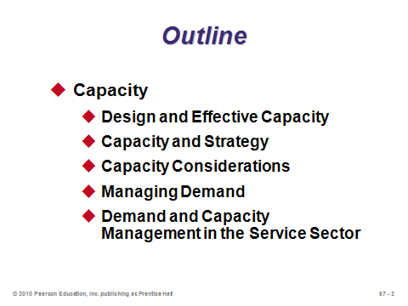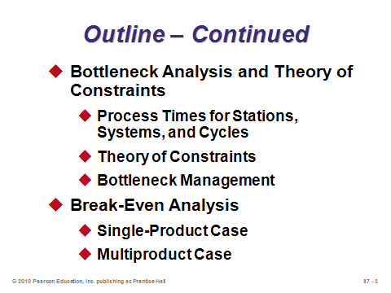

**S7-1 S7-2 S7-3**

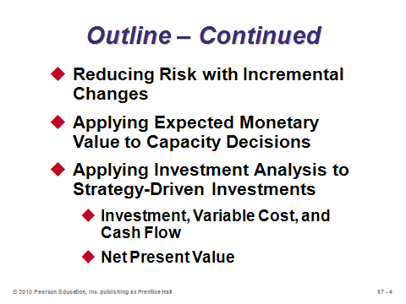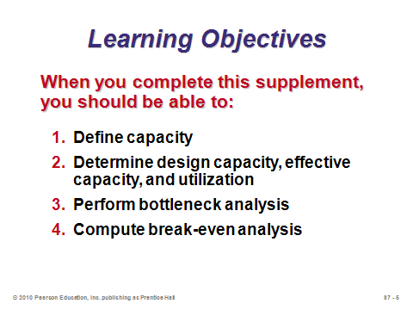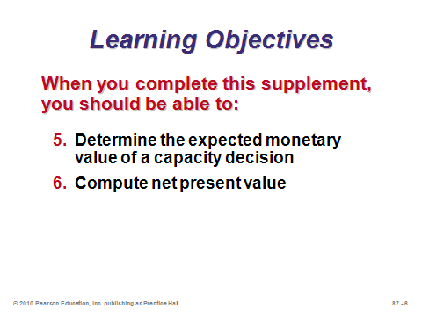

**S7-4 S7-5 S7-6**

CAPACITY (S7-7 through S7-28)

Slides 8-9: These slides define capacity and illustrate how to modify or use capacity under each of the three planning horizons (short-range, intermediate-range, and long-range).

Slides 10-11: These slides define four common capacity-related terms: *design capacity*, *effective capacity*, *utilization*, and *efficiency*. Note that achieving 100% utilization or 100% efficiency may be difficult or even impossible. Operations managers tend to be evaluated on efficiency. The key to improving efficiency is often found in correcting quality problems and in effective scheduling, training, and maintenance.

Slides 12-17: These slides go through the steps of Example S1 from the text, the Sara James Bakery example. Slide 12 computes weekly design capacity. Slide 13 computes utilization. Slide 16 computes efficiency.

Slides 18-19: These slides go through the steps of Example S2 from the text, the Sara James Bakery (continued). Here we see the formula for actual (or expected) output.

Slides 20-22: The strategic importance of capacity decisions is emphasized in Slide 20. Slide 21 identifies four special considerations for a good capacity decision. One of these is *find the optimum operating size (volume)*, which is illustrated in Slide 22 showing economies and diseconomies of scale.

Slides 23-27: These slides cover issues in managing demand. Slide 23 identifies some options for handling situations of demand not matching capacity. Slides 24-26 together illustrate an example of producing products with complementary demand patterns (jet skis and snowmobiles). Other examples might include lawn mowers and snow blowers, basketballs and baseballs, or swimsuits and ski pants. Slide 27 identifies some options for adjusting capacity up or down to better match a fixed demand rate.

Slide 28: This slide touches on demand and capacity management levers commonly employed in the service sector. Appointments and reservations can allow service businesses more control over the timing of demand than a typical manufacturing firm might have. An additional demand management technique is to provide off-peak pricing to smooth out demand over a day (e.g., rush-hour movie specials), a month (e.g. Costco coupons only valid for a two-week period in the latter half of the month), or even a year (e.g., deep discounts at ski resorts during summertime).

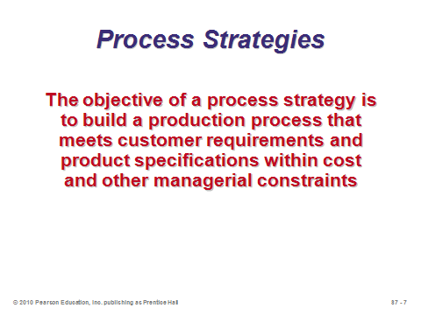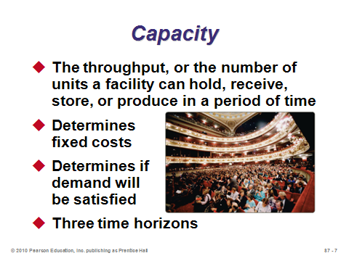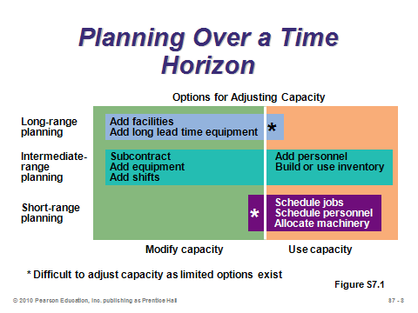

**S7-7 S7-8 S7-9**

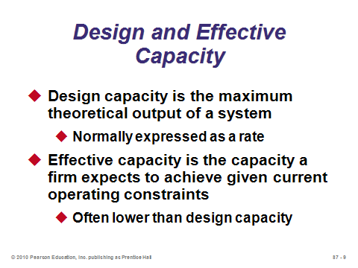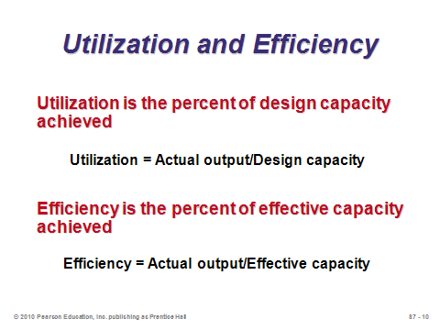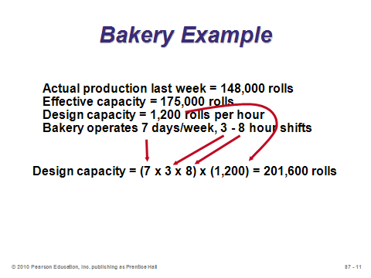

**S7-10 S7-11 S7-12**

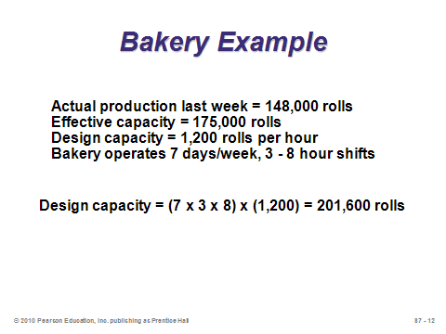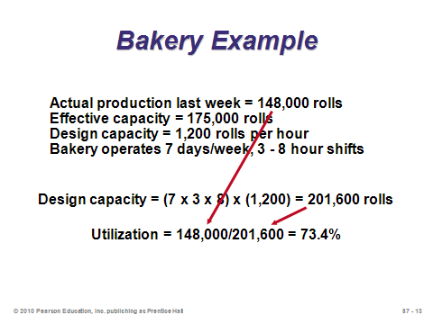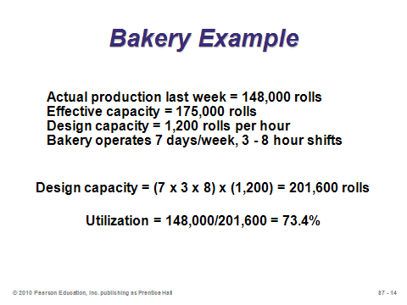

**S7-13 S7-14 S7-15**

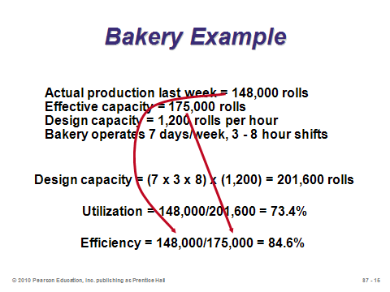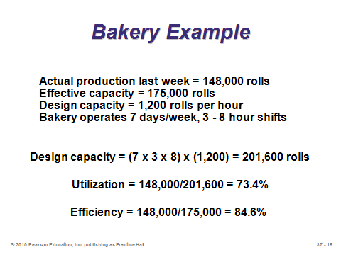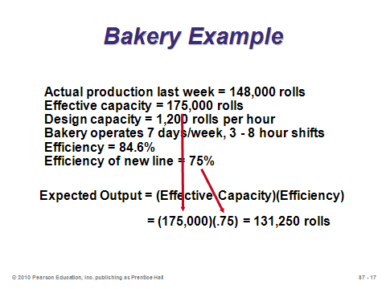

**S7-16 S7-17 S7-18**

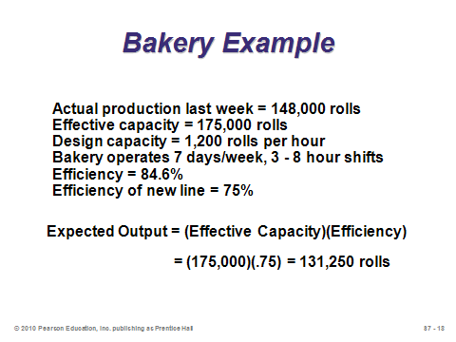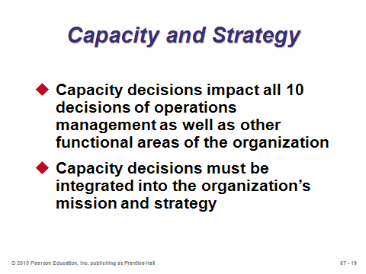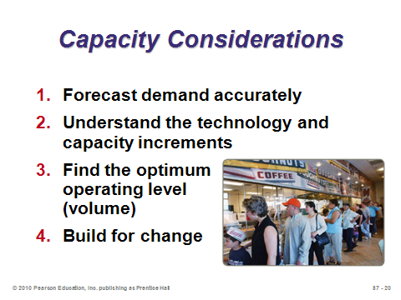

**S7-19 S7-20 S7-21**

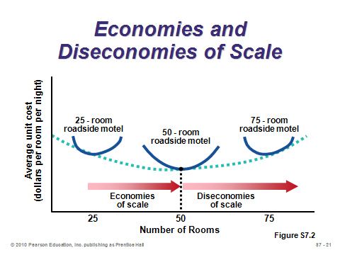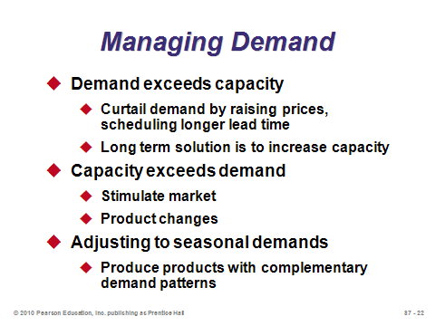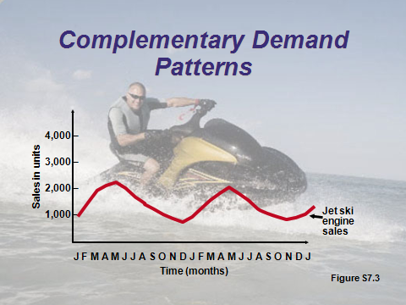

**S7-22 S7-23 S7-24**

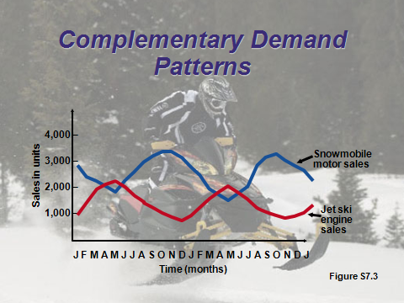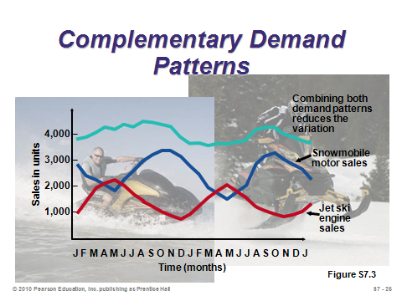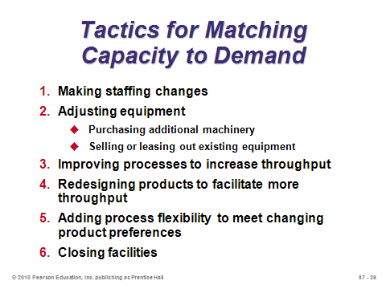

**S7-25 S7-26 S7-27**

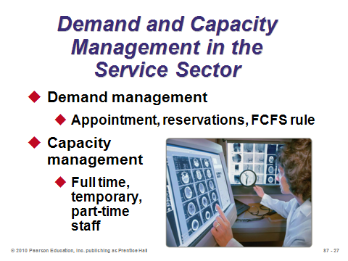

**S7-28**

BOTTLENECK ANALYSIS AND THE THEORY OF CONSTRAINTS (S7-29 through S7-38)

Slides 29-32: This section covers a topic often ignored in introductory operations management books but that is crucial for anyone analyzing processes—bottleneck analysis. Just as a chain is not stronger than its weakest link, a production system can produce no faster than its slowest station (bottleneck). Therefore, operations managers must learn to identify the bottleneck(s) in a process and focus on improving its (their) capacity to increase the throughput of the entire system. Goldratt’s and Cox’s popular book, *The Goal: A Process of Ongoing Improvement*, 3rd rev. ed. (Great Barrington, MA: North River Press, 2004) describes the bottleneck phenomenon very well; however, it leaves out the details of how to actually identify the bottleneck (which may not always be obvious). Many students have a surprisingly difficult time grasping the concepts illustrated in the examples in this section. Slide 29 provides the definition of bottleneck. Important process analysis definitions are provided in Slide 30. Students sometimes have a hard time understanding why process time of a system may be so different from process cycle time. An automobile assembly line can be a good example to try to show the difference. An efficient and balanced, conveyor-belt controlled, assembly line might have stations with 60-second cycle times; thus, a new car is produced on the line every 60 seconds (process time of the system). However, a brand new car might take 30 hours to produce from scratch (process cycle time). Therefore, process time of the system determines its capacity, while the process cycle time determines potential lead time for new orders. Slide 31 can be used to try to illustrate the basic concepts. The longest station in this assembly line is Station B at 4 minutes per unit. Thus, B is the bottleneck and the process time of the system is 4 min./unit. It doesn’t matter how fast Stations A and C can produce—the system cannot pump out a product any faster than one every 4 minutes. (This can be illustrated by moving pennies (products) through the assembly line and recording the completion times of each product at each station.) A 4-minute system process time implies a production capacity of (1 unit/4 min.)(60 min./hr.) = 15 units per hour. On the other hand, process cycle time is computed by adding up the total time to send one unit through the system without any waiting. In this example, the process cycle time is 2 + 4 + 3 = 9 minutes. Slide 32 adds a twist to the system process time definition by accounting for stations with parallel operations. For example, if Station B had two workers who could each produce a product in 4 minutes, then the process time of Station B would have been 4/2 = 2 min. per unit.

Slides 33-34: These slides summarize Example S3, which incorporates parallel operations. Slide 34 includes all of the calculations, and helpfully puts the process flow chart at the top of the slide. Instructors should point out that process times are divided by two when there is a parallel operation, but process cycle times are *not* divided by two because one unit must still be processed for the full length of time at each station. It may help to explain why it makes sense to divide by 2 for the process times of the toasters. If start times are staggered, say, every 20 seconds, then a new sandwich comes out of the toasters every 20 seconds, even though it takes 40 seconds to toast any particular sandwich. If helpful, instructors can illustrate this point using pennies on the flow chart and recording completion times at each station.

Slides 35-36: These slides summarize Example S4, which incorporates simultaneous processes. Slide 35 includes all of the calculations, and helpfully puts the process flow chart at the top of the slide. The important point in this example is that the computation of process cycle time does not involve simply adding all times in the system together. Due to simultaneous processing, the time of each path through the system must be computed—with the longest path representing the process cycle time.

Slide 37: This slide identifies the five steps of the theory of constraints, popularized in *The Goal*. This approach applies to managing bottlenecks and more broadly to anything that limits or constrains an organization’s ability to achieve its goals.

Slide 38: This slide identifies four principles of bottleneck management. Principle 1 warns not to release orders into the system any faster than the bottleneck’s pace. Principle 2 implies that the bottleneck should always be kept busy with work (e.g., don’t let bottleneck workers take breaks without available replacement workers). Principle 3 warns not to produce faster than the bottleneck’s pace at non-bottleneck stations. Principle 4 implies that improvement efforts should focus on the bottleneck.

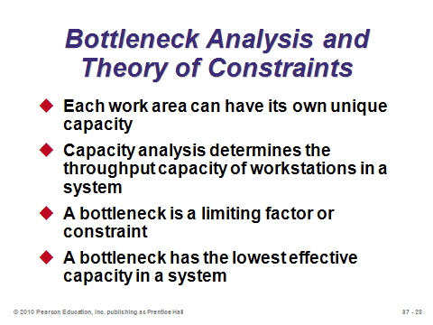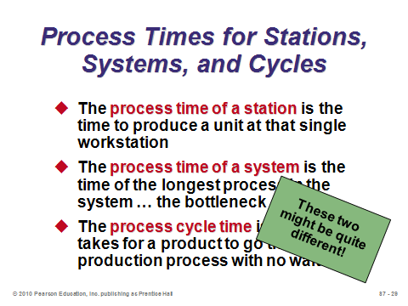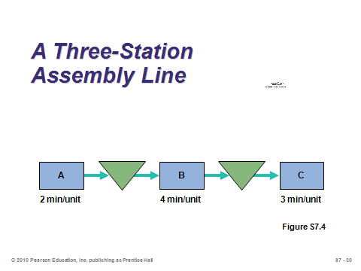

**S7-29 S7-30 S7-31**

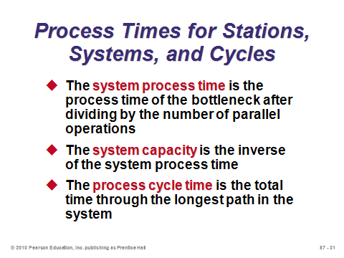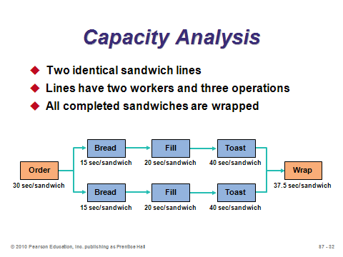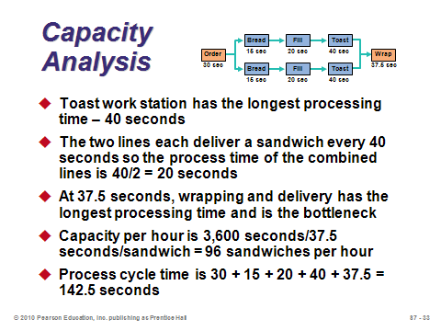

**S7-32 S7-33 S7-34**

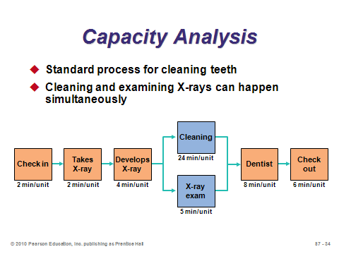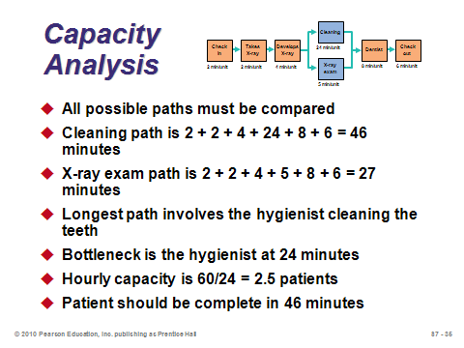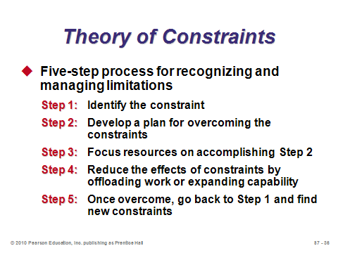

**S7-35 S7-36 S7-37**

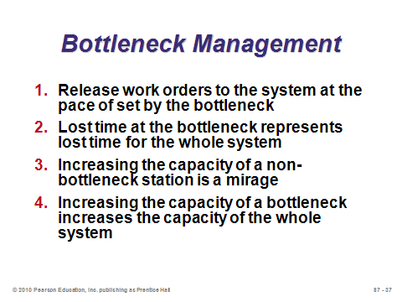

**S7-38**

BREAK-EVEN ANALYSIS (S7-39 through S7-51)

Slides 39-47: These slides provide the foundation for and an example of break-even analysis, which is the critical tool for determining the capacity that a facility must have to achieve profitability. Slide 39 provides the definition, objective, and requirements. Slide 40 describes the two different types of costs considered: fixed and variable. Slide 41 identifies limitations of using the simple linear break-even analysis approach. The graph in Slide 42 suggests that approximately 475 units must be produced and sold in order to start making a profit. Slides 43 and 44 provide the necessary formulas, which can all be derived with some simple algebra. Slides 45-47 present Example S5. Note that the graph in Slide 47 is not presented in the text.

Slides 48-51: These slides present the multiproduct break-even analysis. Slide 48 presents the formula for the break-even point in dollars. Slides 49-51 present Examples S6 and S7.

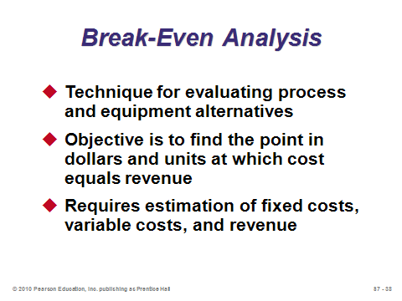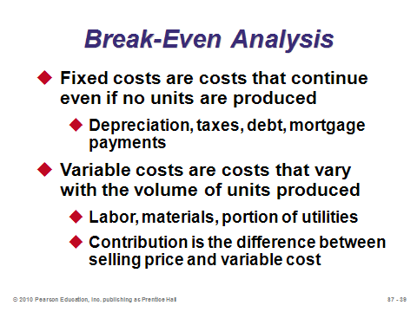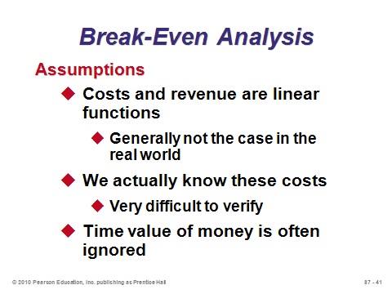

**S7-39 S7-40 S7-41**

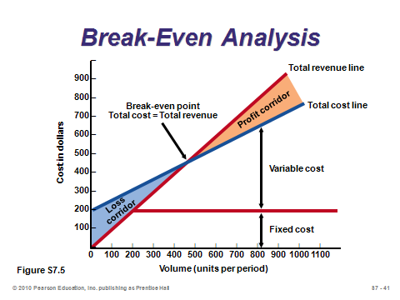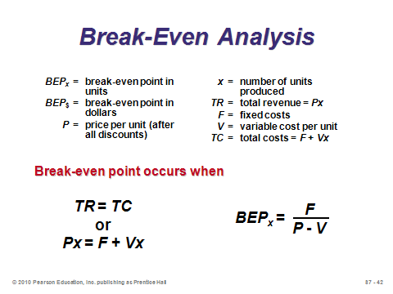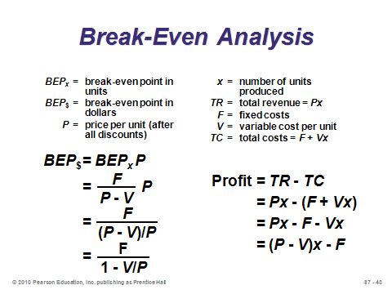

**S7-42 S7-43 S7-44**

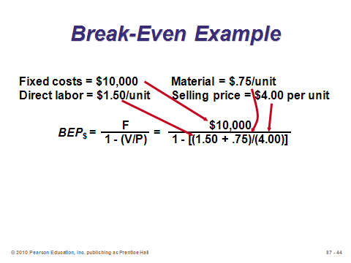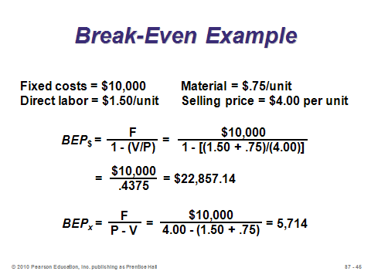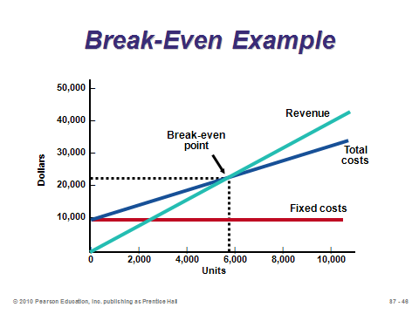

**S7-45 S7-46 S7-47**

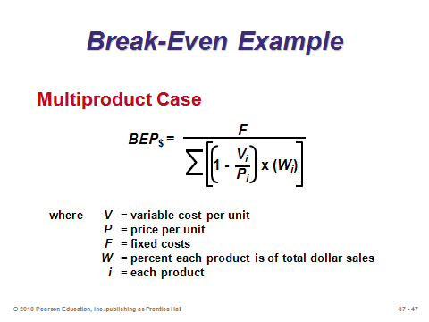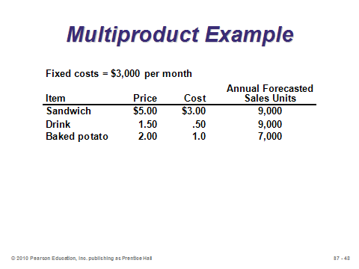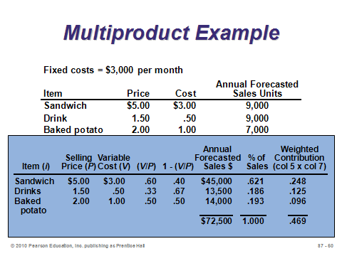

**S7-48 S7-49 S7-50**

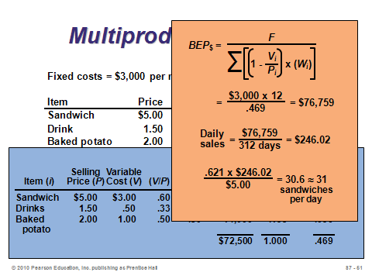

**S7-51**

REDUCING RISK WITH INCREMENTAL CHANGES (S7-52 through S7-55)

Slides 52-55: Slide 52 displays the three approaches to adding new capacity: leading, lag, and straddle. The next three slides show focus on each graph individually. A leading strategy captures all demand, but at the cost of excess capacity for certain time periods. A lag strategy never underutilizes capacity, but may be unable to capture all demand. A straddle strategy attempts to minimize the disadvantages of the two extreme strategies, while still retaining some of the advantages.

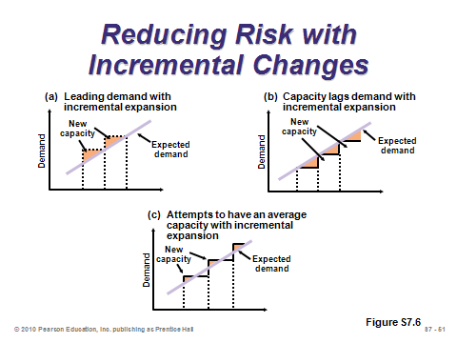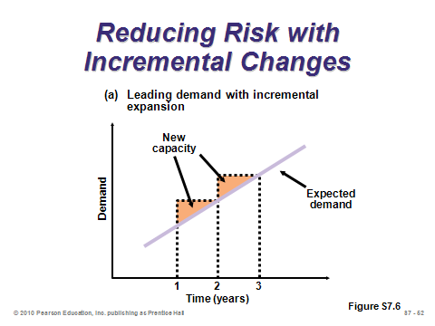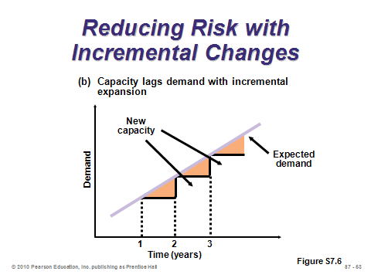

**S7-52 S7-53 S7-54**

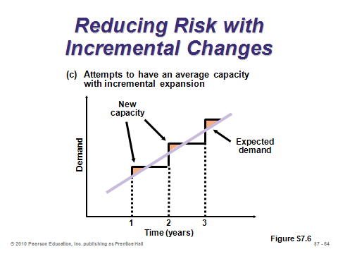

**S7-55**

APPLYING EXPECTED MONETARY VALUE (EMV) TO CAPACITY DECISIONS

(S7-56 through S7-59)

Slides 56-59: Expected monetary value (EMV) computes the expected value of various alternatives, where the probabilities are assigned to various possible future states of nature. These slides present Example S8 from the text. Note that the slides present the analysis in the form of a simple decision tree, whereas the text simply computes the EMV of each alternative and chooses the one with the highest EMV. For straightforward alternatives with only one decision point, a decision tree can help visually but is not necessary to conduct the analysis.

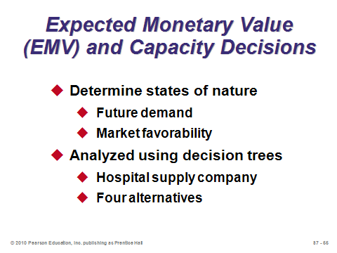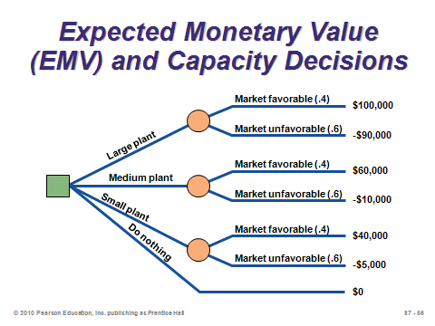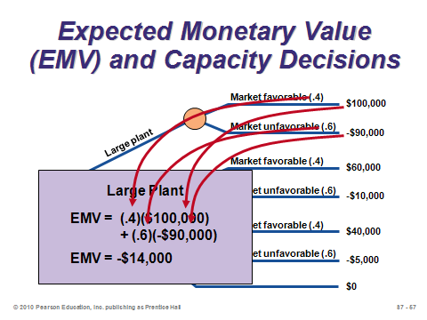

**S7-56 S7-57 S7-58**

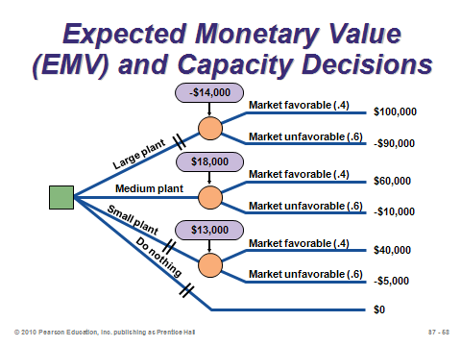

**S7-59**

APPLYING INVESTMENT ANALYSIS TO STRATEGY-DRIVEN INVESTMENTS

(S7-60 through S7-67)

Slide 60: The discipline of finance provides us with the concept of net present value (NPV), which discounts future cash flows to be expressed in today’s dollars. When comparing investment alternatives, the one with the highest NPV is preferable. Although not covered in this short section of the text, it should be noted that taxes and depreciation are important elements in most NPV analyses.

Slides 61-63: Slide 61 presents the basic NPV formula, but Slide 62 warns that it can be cumbersome to implement. Slide 63 shows how to compute NPV using a table such as S7.1 from the text.

Slides 64-66: An annuity is a series of equal payments over time. The present value of an annuity can be easily computed using a table such as S7.2 in the text. These slides present the approach and an example.

Slide 67: This slide identifies some of the limitations of the NPV approach.

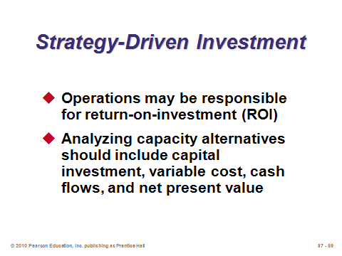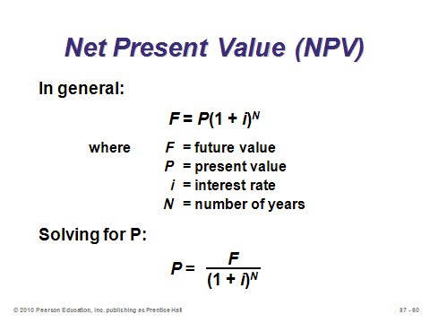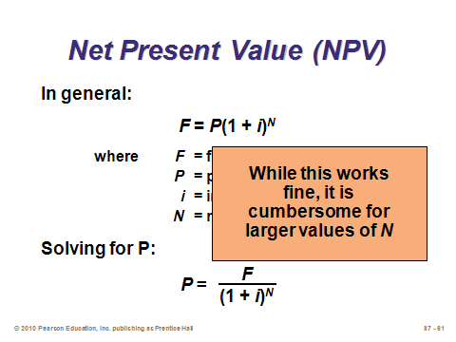

**S7-60 S7-61 S7-62**

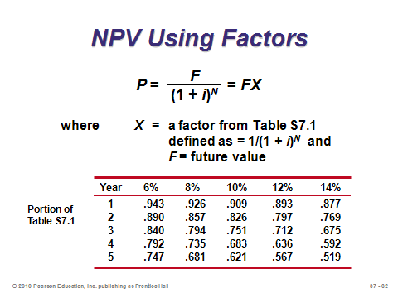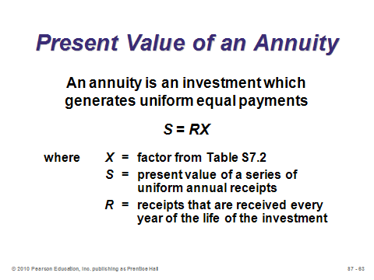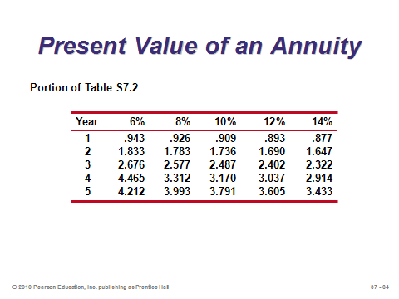

**S7-63 S7-64 S7-65**

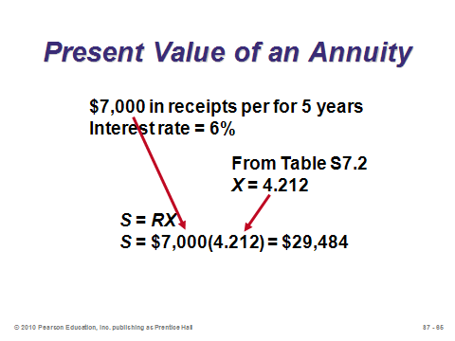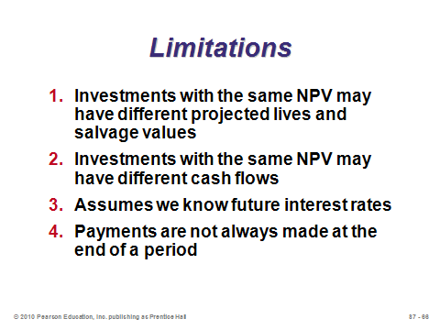

**S7-66 S7-67**

**Additional Assignment Ideas**

1. Monte Carlo Simulation of the Dice Game from *The Goal*

The dice game from *The Goal* (see Active Classroom Learning Exercises above) can be simulated in Excel rather easily. This exercise can be a nice opportunity for students to work on their Excel skills and explore Excel’s random number capabilities. The assignment demonstrates the detrimental effects of dependent events and statistical fluctuations on throughput. Extensions include adding inventory buffers to eliminate dependent events, using a less variable die to minimize statistical fluctuations, exploring where to place the bottleneck in the production line, and examining where to place excess capacity in the production line. A sample set of instructions is provided in Other Supplementary Material below.

2. VisitResearch Works, Inc. (http://www.researchworks.org) and describe their service for capacity planning.

**Additional Case Studies**

Internet Case Study (www.pearsonglobaleditions.com/heizer)

* *Southwestern University's Food Service (D)*: Requires the development of a multi-product break-even solution.

Harvard Case Studies (http://harvardbusinessonline.hbsp.harvard.edu)

* *National Cranberry Cooperative* (#688-122): Requires the student to analyze process, bottlenecks, and capacity.
* *Lenzing AG: Expanding in Indonesia* (#796–099): Considers how expansion affects the company’s competitive position.
* *Chaparral Steel* (#687–045): Examines a major capacity expansion proposal of Chaparral Steel, a steel minimill.
* *Align Technology, Inc., Matching Manufacturing Capacity to Sales Demand* (#603–058): Analyzing and planning production capacity.
* *Samsung Heavy Industries: The Koje Shipyard* (#695–032): Explores manufacturing improvement but falling performance after major capital expansion.

Richard Ivey School of Business (http://cases.ivey.uwo.ca/cases/pages/home.aspx)

* *Halton Recycling, Ltd.* (#9B07D009): The operations manager at Halton Recycling was becoming increasingly dissatisfied with the inefficiency caused by its three-streamed recycling system. City Hall aimed to increase the current 35 per cent waste diversion rate to the provincial goal of 60 per cent within three years.
* *Black Fly Beverage Company* (#9B07D003): The owners of Black Fly Beverage Company consider the viability of expanding their product-line after less than a year in operation. Impressed with their early success, the owners wonder whether they should take advantage of their new brand's momentum and invest in the production of a second product.

**Internet Resources**

|  |  |
| --- | --- |
| American Council of Engineering Companies | www.acec.org |
| Association for Manufacturing Excellence | www.ame.org |
| DARPA: U.S. Defense Dept., Innovative Prototype Systems | www.DARPA.mil |

**Other Supplementary Material**

Options for Capacity Increase

One concept not presented in the textbook that might enhance the lecture is a comparison of options for capacity increase.

On-site expansion

Advantages: generally cheapest, does not disperse existing labor force, no product or process separation, and can take advantage of possible economies of scale

Disadvantages: de-optimizes layout, might postpone the introduction of new technology, increased complexity strains management, larger workforce may cause deteriorated labor relations (possibly unions), and disaster risk

New Branch

Advantages: can use new technology, can design an optimal layout, and can tailor policies and systems effectively

Disadvantages: multi-site overhead and cannot solve problems back at the original plant

Relocation

Advantages: can solve problems at the original plant that is being moved, can use new technology, can design an optimal layout, and can take advantage of possible economies of scale

Disadvantages: moving and startup costs, might lose good people, and disaster risk

Operational Hedging

Another capacity concept is “operational hedging,” which refers to the practice of having excess capacity at plants around the world that is utilized when exchange rates shift favorably. As a quick example, a company has a plant in both the U.S. and the U.K., as well as demand in both countries. A U.S.-based shipper charges $1.00 per unit to ship between the two countries. Assume no taxes. Monthly demand is 10,000 units in the U.S. and 8,000 units in the U.K. Monthly capacity is 15,000 units in the U.S. and 12,000 units in the U.K. The production cost is $6.00 in the U.S. and ₤3.00 in the U.K. (sales prices are irrelevant). We examine three cases. Case 1: the exchange rate is $2 = ₤1. Here the production cost is the same in both countries, so given the shipping cost, each country should produce its own demand. Case 2: the exchange rate is $3 = ₤1 (dollar depreciates). Ask the students what they think might happen. The production cost in the U.K. jumps to ₤9. Thus, even with shipping, production in the U.S. is cheaper. The U.S. plant should maximize its production at 15,000 units and ship 5,000 units to the U.K. The U.K. plant should produce the remaining 3,000 units for the rest of the U.K. demand. Profit will be $10,000 higher than it would have been with no operational hedging. (Interestingly in this example, a weak dollar actually *helps* U.S. workers by bringing more business to the U.S. factory—a weak dollar may be good or bad depending on whether one is buying or selling.) Case 3: the exchange rate is $1 = ₤1 (dollar appreciates). Now the U.K. production cost falls to ₤3. Thus, even with shipping, production in the U.K. is cheaper. The U.K. plant should maximize its production at 12,000 units and ship 4,000 units to the U.S. The U.S. plant should produce the remaining 6,000 for the rest of the U.S. demand.

**Sample Monte Carlo Simulation Excel Assignment for the Dice Game in *The Goal***

Part A

Computer simulations allow managers to approximate real-world phenomena without going through the expense of actually setting up and running the system. For this assignment, you are going to use an Excel spreadsheet to simulate the match game described in Chapter 14.

You will use random numbers (dice rolls) to run the 5-person game for **125** rounds and observe the average throughput at each station (for each person). First, to use the random number functions, you need to ensure that the “Analysis ToolPak” is installed. Go to any cell in the spreadsheet and type “**=RANDBETWEEN(1,6)”** (without the quotation marks). If you get an error message, then you need to install the ToolPak.

Your spreadsheet should have 15 columns. Label the first one “Round Number.” Label the second and third “Andy’s Roll” and “Andy’s Thrput,” respectively. Label the next three columns “Ben’s Bowl,” “Ben’s Roll,” and “Ben’s Thrput,” respectively. Label columns 7-9 like columns 4-6, with “Ben” replaced with “Chuck.” Label the final six columns similarly for the other two players “Dave” and “Evan.” (Note that we don’t need a column for Andy’s Bowl, because his “bowl” is the whole box of matches which is (effectively) infinitely large.)

You should have **125** rows of simulated numbers, one for each round. Andy’s throughput will always equal Andy’s Roll because he can draw from the whole box of matches. However, the throughput for the other players will equal the minimum of the number of matches in their bowl for that round and their respective dice rolls. A player’s “Bowl” amount for round X will equal that player’s “Bowl” amount in round (X-1) **minus** the throughput for that player in round (X-1) (i.e. the amount that he passed on) **plus** the throughput from the previous player in round X. For example, if in Round 3 Chuck’s bowl contains 7 matches and his die roll in Round 3 is 4, then the “Chuck’s Thrput” column for Round 3 will be 4 (the minimum of the matches in his bowl and his roll). Then suppose that “Ben’s Thrput” in Round 4 is 2. In that case, “Chuck’s Bowl” for Round 4 will equal 5 (because he had 7 in Round 3, then he moved 4 out, then he received 2 more from Ben in Round 4).

You can use the **MIN** command in Excel to take the minimum of two numbers (specifically the “bowl” amount and the “roll” amount). For example, to take the minimum of the numbers in cells A1 and B1, use the command “**=MIN(A1, B1)”** (without quotation marks).

To simulate the roll of a six-sided die, use the command “**=RANDBETWEEN(1,6)”** (without quotation marks). This will return a pseudo-random integer number between 1 and 6. Every time that you change a cell in the spreadsheet, that number will change. Once you have the spreadsheet set up and all of the formulas entered, copy the **RANDBETWEEN** command in all **125** “roll” rows for each of the five players. You can simulate **625** new rolls by pressing the <F9> key.

At the bottom of your spreadsheet, calculate the average throughput for each of the five players (by using the **AVERAGE** command in Excel). Run the simulation **15** times by pressing the <F9> key **15** times and record the average throughput for each player for all **15** simulations. (Note that by doing this, you are simulating **9375** total dice rolls in just seconds.)

Deliverables for Part A

1. One copy of the entire spreadsheet for *one* of your **15** simulations.

2. A copy of just the first three rounds from your spreadsheet with the formulas showing instead of the numbers. Be sure to widen your columns enough that the entire formulas can be seen. It will probably help to use the “Landscape” page setup orientation when printing the formulas.

3. A sheet of paper (either typed or handwritten) containing the average throughput amounts for *each* of your **15** simulations for each player. Also, write a paragraph describing any conclusions that you can derive. Specifically, are the average throughput amounts different among the five players, and do those averages change with different simulation runs (i.e. every time that <F9> is pressed)? Why do you think that these observations are occurring?

Hint: You have a mistake in your spreadsheet if it contains negative numbers or if any of your throughput columns contain a number greater than 6. Note, however, that some of the entries in your bowl columns will likely exceed 6.

Part B

Next let’s play with the rules of the game a bit. In particular, the match game effectively illustrates the effects of “dependent events” and “statistical fluctuations” *together.* We now explore what happens when these effects are diminished.

1. One use of buffer inventory stock is to decouple operations and eliminate dependencies among stations. Save your spreadsheet under a new name. Put 100 matches in the four “bowl” cells for round 0. Run the simulation **10** times (i.e. press the <F9> key **ten** times). Write on a sheet of paper (either typed or handwritten) the average throughput amounts for each of your **10** simulations for each player. How do the results differ from your simulations in Part A? What’s the obvious disadvantage of this implementing this approach?

2. Open your base case (Part A) spreadsheet again, and save it under a new name. This time, reduce the variability (i.e., the “statistical fluctuations”) of your processes (your die rolls). To do that, pretend that you flip a coin. Heads means a potential throughput of 3 and tails means a potential throughput of 4. Specifically, change all of your roll columns from “**RANDBETWEEN(1,6)”** to “=**RANDBETWEEN(3,4)”**. Notice that the expected value of each roll is the same (3.5), but the variance has decreased. Run the simulation **10** times (i.e. press the <F9> key **ten** times). Write on a sheet of paper (either typed or handwritten) the average throughput amounts for each of your **10** simulations for each player. How do the results differ from your simulations in Part A?

Part C

Let’s introduce a bottleneck into the system and test Alex’s ideas about how the placement of the bottleneck affects the total inventory in the system. Open your base case (Part A) spreadsheet again, and save it under a new name. To calculate total inventory, we need to add the matches in all four of the bowls. Use the **SUM** command in Excel to add up all **125** rows in the four “Bowl” columns. Then insert a formula at the bottom of your spreadsheet that adds those four total bowl amounts together. This represents the total inventory in the system over the course of the game. (In real plants, companies pay holding cost for every period (round) that they hold inventory.) We will introduce a bottleneck by rolling a 4-sided die instead of a 6-sided one, i.e., changing “=**RANDBETWEEN(1,6)”** to “=**RANDBETWEEN(1,4)”** for *one* of the players. For each bottleneck placement (scenario) below, run the simulation **15** times and record the total inventory each time. Then calculate the average inventory for that scenario (averaged over the **15** simulations). (Show all of these amounts in one table.) Compare your three scenarios. Where should the bottleneck be placed?

*Scenario 1: Andy is the bottleneck.*

*Scenario 2: Chuck is the bottleneck.*

*Scenario 3: Evan is the bottleneck.*

Part D

Finally, let’s explore the effects of introducing excess capacity into the system. Open your spreadsheet from Part C, and save it under a new name. Suppose that one of the players gets to roll two dice instead of one (and the other four players roll one die as in the base case). The formula to represent two thrown dice is “=**RANDBETWEEN(1,6)+RANDBETWEEN(1,6)”**. *Question: Why couldn’t we enter “=RANDBETWEEN(2,12)”?* First give Andy the extra die. Run the simulation **20** times and record the total inventory, as well as Evan’s throughput, each time. Compute the average inventory and average throughput for Evan. Now repeat by giving Evan the extra die instead of Andy. Compare your two scenarios. Who should get the extra die?